


Web Scraping and Analysis
Analyze Hotels in Egypt



Prepared By
Yahya Mahmoud Zakaria
Yousef Ahmad Mohamad
Yahya Mustafa Mohamad
Hamed Abdelrahman Saad
Ahmad Rashad Elsayed

Prepared On
10/4/2025



GitHub Link
https://github.com/yahia997/Scrapping-Project

Website
We chose https://booking.com as our destination of data.

Data we will scrap
Attribute | Information (Example)
Hotel Name | Four Seasons Hotel Alexandria At San Stefano
Location. | 399 El Geish Road , San Stefano, 21599 Alexandria, Egypt
Description. | More info about the hotel
facilities | - 3 swimming pools (1 open)  - Spa  - Fitness center  - Restaurant (temporarily closed)
Comments | "name": "…",  "country": "…",  "description": "…"
Number of reviews
Rating | Up to 10
rating_details | "Staff ": "8.7",  "Facilities ": "8.1",  "Cleanliness ": "8.3",  "Comfort ": "8.3",  "Value for money ": "7.7",  "Location ": "9.0",  "Free Wifi ": "7.3"
longitude and latitude | (31.231793499770284,29.94602680206299)

We will get data about hotels in Egypt in the following cities:

Alexandria

Cairo

Hurghada

Sharm El Sheikh

Ain Sokhna

Dahab

Port Said

North Coast

Fayoum

Aswan

Marsa Alam

Ismailia

Tools and Technologies

Scrapping
    - Selenium: for putting search keywords (city names) and to interact with the HTML elements.
    - BeautifulSoup: After getting each hotel link we will need to scrap it individually to get more data about each hotel, as bs4 is much easier to implement.

Other python libraries:
    - Pandas.
    - Numpy.
    - Matplotlib.
    - Seaborn.
    - Pymongo.
    - re.
    - other if needed

MongoDB Atlas:
    - MongoDB Atlas offers 500MB for free to use at the cloud, so that any one can access our data from anywhere in addition to making implementation easier.
    - Why we chose MongoDB?
We will use MongoDB not because the assignment mentions it but for the following reasons: MongoDB is suitable for scrapped data as it stores it in JSON format, sharding, scalability, aggregation pipeline, MongoDB is suitable for data analysis applications.

Pipeline
Scrapping
Data analysis and visualization
Load to MongoDB
Data Preprocessing

Deploy to Streamlit

More Details about each Step:

Scrapping:
We scrapped our data already using selenium and bs4 and here are some screenshots of scrapping process and the output.
We scrapped the information mentioned above about 600 hotels.
This is a sample of a single hotel:
{
"title": "Tolip Hotel Alexandria",
"address": "31.231793499770284,29.94602680206299",
"description": "This 5-star hotel in Alexandria offers an outdoor pool, a spa and a gym. It features modern accommodations with views of the sea or city. Free Wi-Fi is available in public areas.\n\nAir-conditioned rooms are equipped with a mini-bar and flat-screen satellite TV. Each suite comes with a living room and a dining table. Featuring a bathtub and shower, private bathrooms are stocked with free toiletries. All rooms have a balcony.\n\nGuests can choose to dine at any of the hotel’s 9 dining outlets, which serve a variety of cuisine ranging from local to international. The pool bars are an ideal place for relaxation.\n\nThe hotel is 1312 feet from Al-Salam Theater and Stanley Bridge, and is 0.9 mi from Sidi Gaber Railway Station. Borg el Arab International Airport is 26 mi away. The property offers parking at an extra cost.",
"address2": "Moustafa Kamel, Corniche Road Roshdy, Alexandria, EgyptExcellent location – rated 9/10!(score from 11774 reviews)Real guests • Real stays • Real opinions",
"facilities": [
"Outdoor swimming pool",
"Free Wifi",
"Private Parking",
"Family rooms",
"Spa",
"Fitness center",
"5 restaurants",
"Room service",
"Bar",
"Good Breakfast",
"Outdoor swimming pool",
"Free Wifi",
"Private Parking",
"Family rooms",
"Spa",
"Fitness center",
"5 restaurants",
"Room service",
"Bar",
"Good Breakfast"
],
"reviews_cnt": "11,774 reviews",
"rating": "Scored 8 ",
"rating_details": {
"Staff ": "8.7",
"Facilities ": "8.1",
"Cleanliness ": "8.3",
"Comfort ": "8.3",
"Value for money ": "7.7",
"Location ": "9.0",
"Free Wifi ": "7.3"
},
"comments": [
{
"name": "Elsayed Kuwait“The rooms just need a bathrobe and an iron but the stay is excellent”Read more",
"country": " Kuwait",
"description": " Kuwait"
},
{
"name": "Gehan Egypt“Staff were very friendly, cleanliness was above expectations”Read more",
"country": " Egypt",
"description": " Egypt"
},
{
"name": "Mohamed Egypt“would like to express my sincere appreciation for the exceptional service provided by the reception staff during my stay. Their professionalism, kindness, and attentiveness made a remarkable impression and greatly enhanced my overall experience at...”Read more",
"country": " Egypt",
"description": " Egypt"
},
{
"name": "Ali United States“I have found that the staff was very professional and courteous in general. Ahmed at the front desk was very helpful, and so was the housekeeping staff.”Read more",
"country": " United States",
"description": " United States"
},
{
"name": "Amal Saudi Arabia“Great location, very clean, excellent breakfast buffet,”Read more",
"country": " Saudi Arabia",
"description": " Saudi Arabia"
},
{
"name": "Mahmoud Egypt“Special thanks to Shereif and Khamis they are very friendly staff”Read more",
"country": " Egypt",
"description": " Egypt"
},
{
"name": "Hisham Egypt“The joy started with smooth check in and free upgrade from that wonderful girl receptionist and ended with smooth check out.\nAll between are very wonderful. View, clean place, food, car parking, location and finally all the staff.”Read more",
"country": " Egypt",
"description": " Egypt"
},
{
"name": "Raouf Egypt“Room service & Staff in general were exceptional.\nSherif Awad\nKhamis Zahran”Read more",
"country": " Egypt",
"description": " Egypt"
},
{
"name": "Mohamed Egypt“the atmosphere and family concept of hotel \nand friendly staff \nhouse keeping staff Ali ,mohamed and Awad”Read more",
"country": " Egypt",
"description": " Egypt"
},
{
"name": "Mohamed Egypt“Very friendly staff. The reception team gave me a free upgrade. Thanks Tolip team.”Read more",
"country": " Egypt",
"description": " Egypt"
}
]
}

It takes me more than 40 minutes to scrap this data.
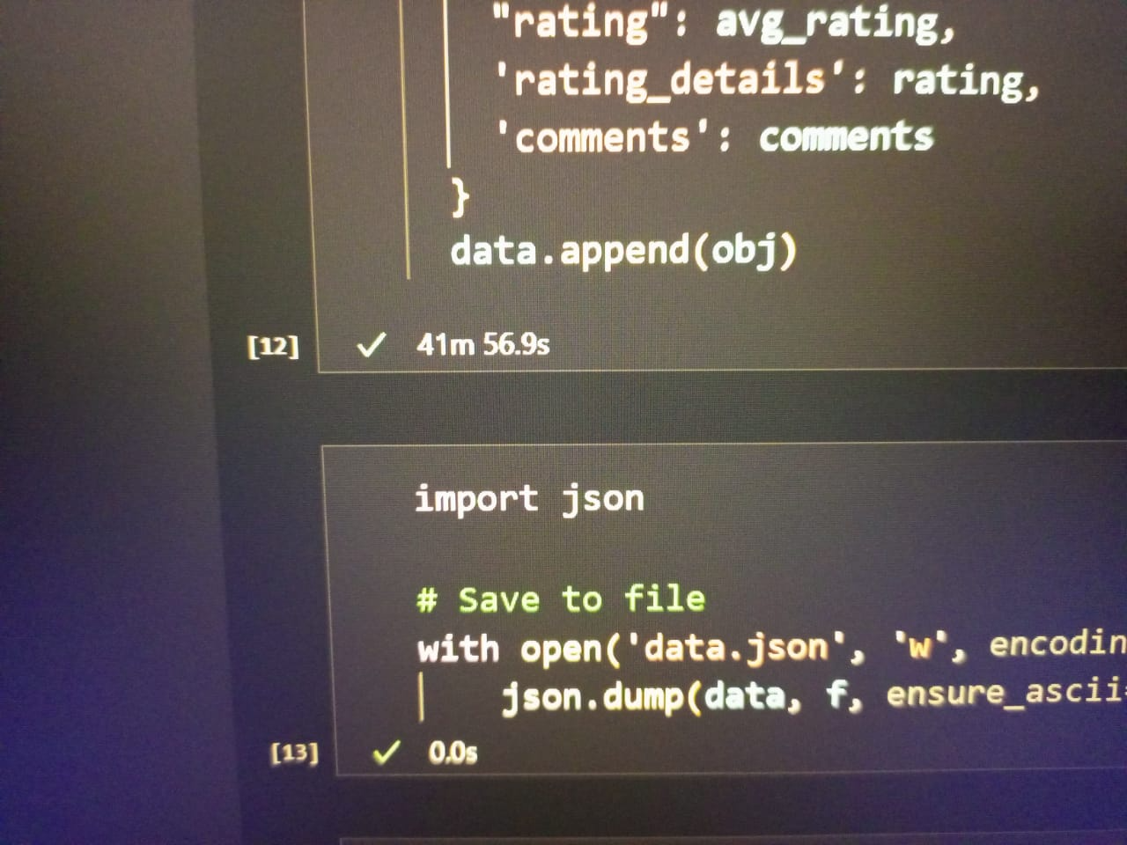

Data preprocessing:
As our data in JSON format we will loop through each hotel and preprocess it rather than using pandas dataframe.
We will not use Spark RDDs as it is well suited for huge data.

From the scrapped data we need to apply the following:
    - "address":
Which is longitude and latitude need to be parsed with regrex and separate them in list.
    - "address2":
We need to extract City, country and remove extra data from it using regrex.
    - "reviews_cnt":
Extract number from it.
    - "rating":
Extract number from it.
    - "comments":
Comment name, country and description are merged all in name attribute we need to handle that (regrex).
    - "facilities":
Remove duplicates.
    - "description":
Remove <h2></h2>.
    - Remove duplicates from all data.
    - Handle missing data at all.
    - Handle extra white spaces.
    - Check outliers, wrong and inconsistent data such as negative rating.
    - Other if needed.

Load to MongoDB Atlas
We will deploy before analysis to make any person capture data from any where and make his analysis (As in real projects).
We make that also to benefit from MongoDB Aggregation pipeline which will enable us make analysis more easily and faster (we will use python libraries If needed).

Data analysis and visualization:
Visualization and analysis we will make:
    - WordCloud for Negative reviews to detect common complaints (we can detect the things that make people love and hate).
    - Number of hotels in each City. (Bar/pie/Treemap).
    - Compare the frequency of each facility and rating.
    - Radar Chart of each hotel to compare different metrics of ratings.
    - Average rating for some great brands (barh).
    - Some Correlations and relationships such as (we can use heatmap, scatter plot between numeric values): location and rating.
    - Boxplot and histogram to see distribution and outliers in ratings.
    - Which countries leave the most reviews?
    - Geographic heatmap to see rating for each governorate and number of hotels.
Another advanced thing we may add:
- Predictive model to predict the rating of the hotel based on provided facilities (may be decision tree/random forest or multiple linear regression)
- Recommend similar hotel using cosine similarity (explained theoretically on lectures)
some of challenges may be size of the data as it may take days as internet is slow to collect large amounts of data for these tasks.

TimeLine
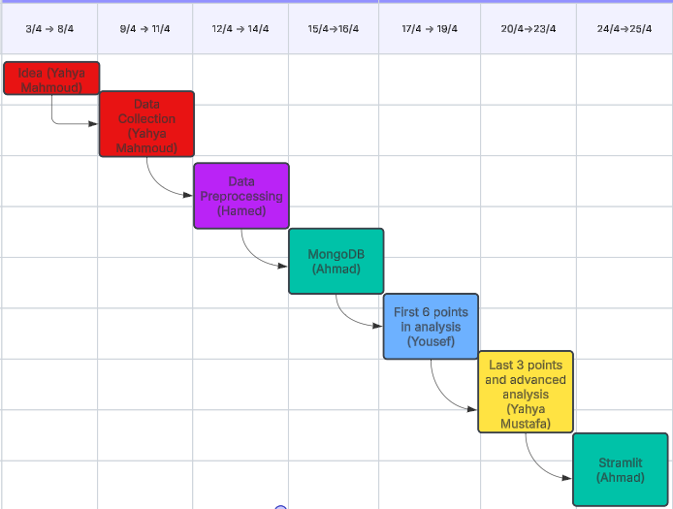
Thanks

